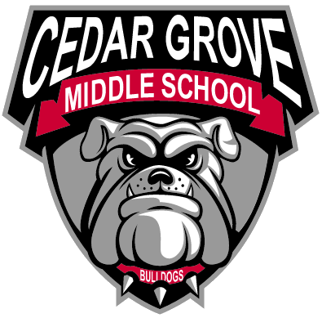

750 Grove Trail, SW

Supply, NC 28462

Phone (910) 756~6120

Fax (910) 294~4068

## Justin Hayes

Principal

### Jody Holloway

Assistant Principal

November 13, 2023

Dear Bulldog Parent/Guardian:

I hope that the school year has gone successfully for all of you. I am writing this letter to let you know, as a parent/guardian of a student at Cedar Grove Middle School, that our school has been designated as a Targeted Support & Improvement – Additional Targeted Support (TSI-AT) school for the subgroup of “Students with Disabilities” by the North Carolina State Board of Education. As stated in ESSA Section 111(d)(2), North Carolina had to identify schools for targeted support and improvement. TSI-AT schools in North Carolina are those that have a subgroup that is under-performing. The intent of this opportunity is to improve educational outcomes for all students, close achievement gaps, increase equity, and improve the quality of instruction.

As a TSI-AT school, Cedar Grove Middle School is required to develop a comprehensive plan that specifically addresses how the school will improve student achievement. The plan will also include how our district will support us and monitor the progress of our school. The comprehensive plan will address the following areas:

* Classroom Management
* Standards-aligned Instruction
* Professional Learning Communities (PLCs)
* Instructional Leadership
* Recruitment and Retention of Effective Teachers
* Support for Grade-to-Grade Transition
* Implementation of a Tiered Instructional System
* Data-Driven Decision Making
* Student Support Services
* Family and Community Engagement

We have set the following goals for Cedar Grove Middle School this year:

* Utilizing data from Educator’s Handbook, Cedar Grove Middle School will decrease discipline referrals by 10% leading to a decrease in instructional days lost for disciplinary reasons. During the 2023-2024 school year, this goal will increase student instructional time and by extension, academic performance.
* Utilizing data from EVAAS, students at Cedar Grove Middle School will increase in both math proficiency, by 12% (+52 students) and growth, by .5 – 1.0, for the 2023-2024 School Year.
* Utilizing data from EVAAS, students at Cedar Grove Middle School will increase in reading proficiency by 12% (+52 students) and growth, by .5 – 1.0, for the 2023-2024 School Year.

Out students need to experience higher achievement levels, but it will require hard work on the part of staff, students, and families. Here are some strategies Cedar Grove Middle School will be implementing:

* All teachers have implemented IXL for both Reading and Math into school-wide daily intervention time which reinforces core instruction and bridges gaps in learning.
* The use of our Math Interventionist as an elective period across all grade levels allows us to focus on math more specifically through the use of individualized instruction and with the help of the Math180 program.
* The continued focus on rigor and relevance throughout the school to increase student proficiency.
* The PBIS team has revised and implemented new procedures to help reinforce positive behaviors at school.
* The MTSS team and SLT team will continue to identify areas of need for students and address as needed.

Parent Engagement is at the heart of our school improvement efforts. Here are some ways that we can work together to ensure the success of our students at Cedar Grove Middle School:

* Be aware of academic expectations set for your student this year. A list of learning objectives is available from your student’s teachers.
* Call Cedar Grove Middle School if you have questions or concerns about your student, or to set up an appointment to meet with their teacher, teacher team, or school staff member that works with your student.
* Make sure your student attends school each day and arrives prepared for school.
* Monitor your student’s grades and progress through the use of Parent Portal. Access can be gained through our Data Manager, Keishonna Hewett, or someone in the front office.
* Keep track of our website, www.bcswan.net/CGMS , and our school Facebook page to stay up-to-date on all things Cedar Grove Middle School.
* Join the CGMS PTA. Information can be found on the school website and the Cedar Grove Middle PTA on Facebook.
* Review the monthly “Bulldog Bytes” newsletter for Parents and Guardians. This can be found linked on our school webpage and Facebook page each month.

This is a great deal of information, but preparing our students so they can succeed is not easy and is a group effort. Here are some resources available to help:

* K-12 standards in academic subjects: [www.ncpublicschools.org/curriculum](http://www.ncpublicschools.org/curriculum)
* State student achievement test results: [www.ncpublicschools.org/accountability](http://www.ncpublicschools.org/accountability)

We are excited about this school year and we are working to make it a success for your student. Already, we have:

* Restructured our school-wide, research-based intervention block specific to each student’s needs in order to grow our students in reading, math, and other content-specific areas.
* Endeavored to reduce referrals and suspensions compared to our previous years data.
* Reinforced continuity with a positive school culture through the consistent use of PBIS best-practices.

If you have questions about the content of this letter, please contact Principal Justin Hayes ([jhayes@bcswan.net](mailto:jhayes@bcswan.net)) at 910-756-6120.

Sincerely,

Justin M. Hayes

Principal, Cedar Grove Middle School